Executive Summary 1
Document AI 2
Address the Document Burden in Health 2
Document AI for Health 3
Core Capabilities 4
Path from Upload to Record 5
Extract Data from Health Documents 5
Process a Referral from Upload to Record 5
Upload the Document 6
Extract the Data 6
Review and Match the Results 7
Save to Records 9
Set Up, Scale, and Run an Extraction 10
Configure and Trace an Extraction 10
Start with a Standard Template 10
Configure How a Template Extracts Data 11
Set Up Batch Processing 13
Trace a Run from Document to Records 14
Wrap Up 15

Executive Summary
Document AI for Health addresses the manual work required to turn patient referrals, case intake forms, disease definitions, and other unstructured health documents into usable Salesforce data. By combining optical character recognition with generative AI and health-specific extraction templates, it identifies information in supported PDFs and images and maps the results to connected Health Cloud records. This reduces repetitive data entry and makes reviewed document information available for care coordination, case management, disease surveillance, and related workflows.
The processing workflow moves from upload through extraction, transformation, review and matching, and saving. Users compare proposed values with the source document, correct extraction errors, and confirm whether information belongs in existing or new records. Field-level confidence scores help prioritise review, but do not establish clinical correctness. For referrals, the saved Clinical Service Request connects the patient with the requested service, while related records preserve clinical, coverage, and other referral information.
Admins configure processing through standard or custom templates, context definitions, object and field mappings, model instructions, confidence thresholds, and optional post-transform and post-save flows. Standard templates support patient referrals, case intake, and disease definitions. Automatic template matching, connected Amazon S3 sources, and scheduled batch processing support varied intake channels and higher document volumes, with configurable review before saving.
Each document is tracked through a Document Extraction Request and its processing steps, retaining the source file and execution history for review, troubleshooting, and reruns. The central value is a consistent path from unstructured documents to connected Health Cloud data: admins establish the extraction configuration, while intake teams use it to review, match, and save information without rebuilding the process for each file.

Document AI

Address the Document Burden in Health
Health organizations receive critical information through documents every day. Patient referrals, case intake forms, disease definitions, lab results, prior authorization materials, and clinical correspondence can arrive as emailed PDFs, portal uploads, scanned packets, or faxes.
Even information inside digital files often isn’t structured for use in a health system. A referral coordinator can still need to identify the patient, confirm the referring provider, interpret the requested service, review coverage information, and enter each detail into the appropriate records. Similar work occurs when teams process intake forms or prepare disease information for surveillance workflows.
That manual intake creates more than an administrative burden. A referral can’t move toward review and scheduling until its information is captured correctly. A case can’t enter the appropriate workflow until staff classify and record its details. And information contained in a document can’t reliably drive automation, reporting, or coordinated follow-up while it remains only text in an attached file.
Document AI for Health helps close that gap. It extracts information from unstructured health documents, organizes the results according to a defined data structure, and maps them to Salesforce records for review and use.
In this badge, you learn how Document AI for Health processes a document from upload through extraction, review, matching, and saving. You also explore the templates, context definitions, mappings, and batch-processing options that admins use to support different document types and intake volumes.

Document AI for Health
Document AI for Health turns information contained in health documents into structured Salesforce data. It uses optical character recognition (OCR) to capture text from PDFs and images, and then uses generative AI to identify the values defined by an extraction template.
The template specifies what information to extract and how to map it to Health Cloud objects and fields. For a patient referral, for example, the feature can identify patient details, the referring provider, the clinical reason, coverage information, and the requested service. It returns those values with confidence scores so a user can review the results, match them to existing records, and save the confirmed data.
Document AI for Health includes standard templates for common healthcare documents, mappings to the Health Cloud data model, and records that track each extraction. Users can easily review the extraction results to resolve low-confidence values and record mismatches.
Document AI for Health uses the text, its surrounding context, and the instructions in the selected template to identify those values without relying on one fixed page layout. A referring provider might appear beneath a labeled field in one document, in a letterhead block in another, and within a paragraph in a third. The template defines what the model should identify, while its mappings define where the reviewed values belong.
Because Document AI for Health writes to the shared Health Cloud data model, organizations can use extracted information across the broader Health Cloud portfolio.
A patient referral can supply records used in care coordination. A case intake form can populate information required for a case-management workflow. A disease-definition document can provide structured criteria for disease surveillance. The document type and selected template change, but the underlying pattern stays consistent: unstructured content becomes Health Cloud data that the relevant application can use.
This architecture diagram shows the Health Cloud ecosystem that Document AI for Health operates in.
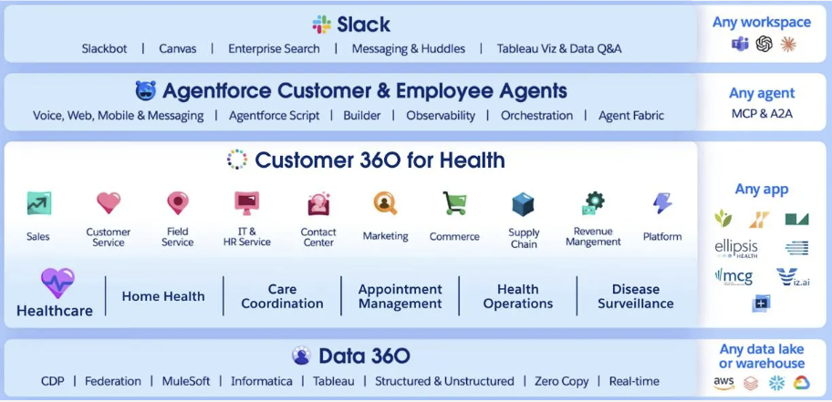
Data 360 provides the underlying data and AI services, while Health Cloud applications use the resulting data across healthcare, home health, care coordination, appointment management, health operations, disease surveillance, and other solution areas. Agentforce agents and Slack can also work with that shared data in the context where teams already operate.

Core Capabilities
Document AI for Health combines document extraction with health-specific configuration, review, and record handling. Its core capabilities include:
- Standard and custom extraction templates: Use prebuilt templates for patient referrals, case intake, and disease definitions, or configure a template for another document type. Each template defines the information to extract and how the results map to Salesforce records and fields.
- Field-level confidence scoring: Review a confidence score for each extracted value and use a configured threshold to identify results that need closer attention before saving documents.
- Support for common document formats: Process PDFs and image files such as JPEG and PNG, including scans, photographs, and supported handwritten content.
- Record matching and reference resolution: Match extracted information to existing records, resolve related references, and avoid creating unnecessary duplicates when you review and save documents.
- Batch extraction: Run extraction against documents placed in a connected folder on a recurring schedule. Admins can also require a review before records are saved.
- Amazon S3 document source: Read files for extraction directly from a connected Amazon S3 bucket, for both single-document and batch runs.
- Automatic template matching: Identify the right template for an incoming document, without manual selection.
Together, these capabilities reduce the manual work between document receipt and record creation. Staff still review low-confidence values and confirm record matches, but they no longer need to locate and re-enter every detail from the source document.

Path from Upload to Record
Before a team can process a document, an admin selects or configures an extraction template for that document type. The template defines what information to identify, how to structure it, and where the reviewed values map in Salesforce. You explore that setup in the final unit.
Stage | What Happens
Upload | A user uploads a supported PDF or image, or a batch job submits a file from a connected folder.
Extract | Optical character recognition captures the document text. The selected model then identifies the entities and values defined by the extraction template and assigns a confidence score to each result.
Transform | The platform organizes the extracted values into the record structure defined by the template and its mappings.
Review and Match | A user compares the proposed values with the source document, corrects low-confidence results, and matches the extracted information to existing records or confirms that new records should be created.
Save | Salesforce creates or updates the connected records and stores the completed extraction request.

The platform can also run configurable steps after the Transform or Save stages, where an organization can insert its own logic, such as enriching a record once it's created. Y

Extract Data from Health Documents

Process a Referral from Upload to Record
The workflow reduces the need to read and re-enter every detail manually, while preserving the review steps required to confirm extracted values and connect them to the correct records.
When a new referral arrives, specialists can upload the document and review the proposed records before making the information available to the care team.

Upload the Document
Patient referrals can arrive as emailed PDFs, scanned forms, faxed letters, or photographs of paper documents. Their layouts and image quality vary by source, but the intake team still needs to identify the same core information and enter it into the appropriate records.
From the App Launcher, Dana finds and selects Document Extraction Request, then selects Extract Document.
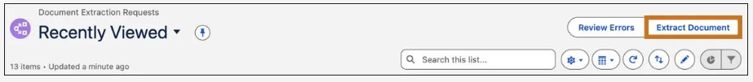
Users can choose a file already stored in Salesforce, upload a new one, or select a file directly from a connected Amazon S3 bucket. In this example, they upload a file and selects Next.
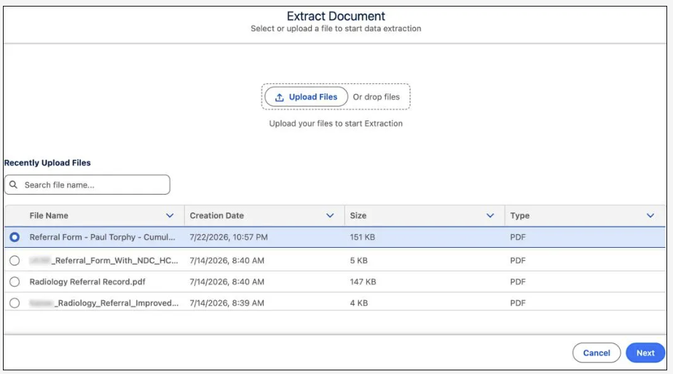
At this stage, the specialist doesn’t need to create a separate intake process for each provider’s layout or delivery channel. Supported PDFs and image files enter the same extraction workflow, where the selected template determines what information the system looks for.

Extract the Data
A patient referral can contain information that belongs across several related records. It may identify the patient and referring provider, describe the clinical reason for the referral, name the requested service, and include coverage details. Intake staff must interpret those relationships correctly before the referral can move forward.
After uploading the file, staff defines the scope of the run on the Review Extraction Configuration page:
- Select Pages determines whether the feature processes the full document or a specified page range.
- Review Template Type identifies the extraction template for the document. You can select a template manually or have the feature auto-identify it.
The selected template defines the entities and attributes the feature attempts to extract. The Records to Extract list shows the target record types configured for that template, including the patient and the clinical service request that connects the referral information.
Staff keeps All Pages, selects the Patient Referral template, reviews the configured record types, and selects Extract.
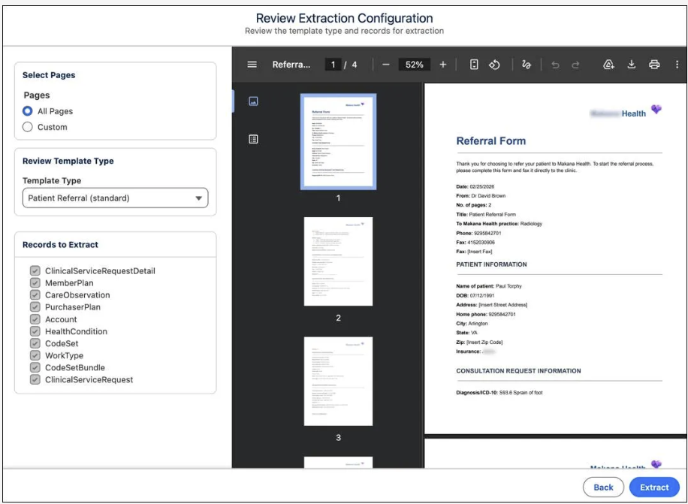

Review and Match the Results
Before extracted information becomes part of the patient record, staff reviews the proposed values and confirms where they belong. An incorrect patient match, diagnosis, referring provider, or requested service can delay the referral or create duplicate and conflicting records.
From the new extraction request, staff opens the action menu and selects View.
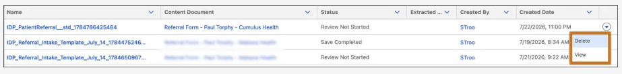
The Extraction Result page brings the source document and the proposed record structure into one review workspace.
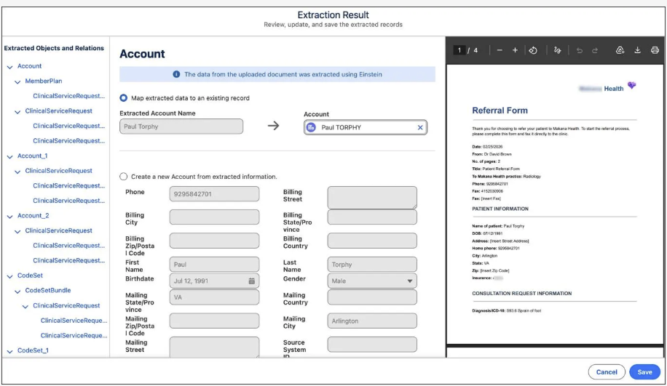
The left panel lists the extracted entities defined by the template. When staff selects an entity, the middle panel shows its proposed field values, confidence scores, and record options. The original referral remains visible in the right panel so she can compare each value with the source.
Staff reviews the entities one at a time. Confidence scores help them identify values that may require closer inspection, but they verify the proposed information against the document before saving. They can correct any extracted value and verify where each entity belongs. By default, the feature automatically matches a patient to an existing account when one already exists, so staff confirms the proposed match rather than searching for it. When there's no match, they create a new record with the confirmed fields already populated.
This review step confirms both the content of the extraction and its place in the Health Cloud data model. By the time staff finishes the review, the referral information is ready to be saved without creating an unnecessary patient record or losing the relationships among the referral, condition, coverage, and requested service.

Save to Records
After confirming the extracted values and resolving the record matches, staff saves the record. Salesforce creates or updates the connected records defined by the Patient Referral template, then shows a Review Extracted Records summary of the saved results.
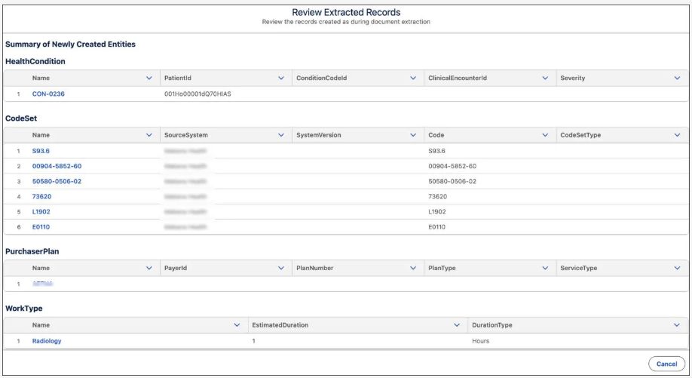
One of those newly created records is the Clinical Service Request, which serves as the anchor for the referral.
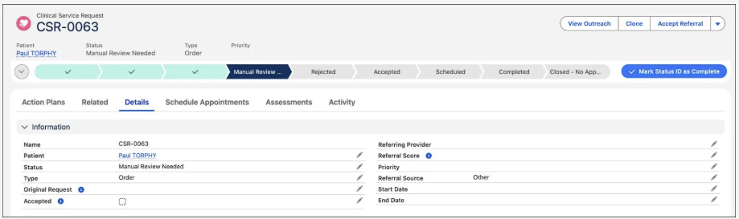
It connects the patient with the requested service and provides the record the care team can use to review, accept, and schedule the referral.
The remaining extracted information is saved in related records according to the Health Cloud data model.
Extracted Information | Saved As
Patient information | An Account record, matched or created
Clinical reason | A Health Condition record and related Clinical Service Request Detail records
Medical codes | CodeSet records, grouped according to the template mapping
Coverage information | Member Plan and Purchaser Plan records
Requested service | A Work Type record
These relationships preserve the structure of the referral rather than placing every extracted value on a single record. They also allow each part of the referral to participate in the workflows and reporting that use that Health Cloud object.
After the records are processed, the status of the extraction request changes to Save Completed. The original document remains available for reference, while its reviewed information is now represented in connected records that the care team can act on through the referral lifecycle.

Set Up, Scale, and Run an Extraction

Configure and Trace an Extraction
An admin first selects or configures a template for the document type. The template defines the entities and attributes to extract, the prompts that guide identification, the mappings to Salesforce records and fields, and the confidence threshold used during review.
When a document is processed, Salesforce creates a Document Extraction Request and tracks the extraction through its component steps. Those steps capture the source text, structure the extracted values, resolve references and record matches, and prepare the confirmed results for saving.

Start with a Standard Template
Each document type requires a defined extraction structure. An admin must specify which entities and attributes to identify, how those values map to Salesforce records and fields, and which prompts and settings guide the extraction.
Document AI for Health provides standard templates for common healthcare documents so admins don’t have to build that configuration from scratch. Each template is paired with a context definition and context mapping that together describe what to extract and where the reviewed values belong.
On the Document AI for Health setup page, admins can start with templates for patient referrals, disease definitions, and case intake forms.
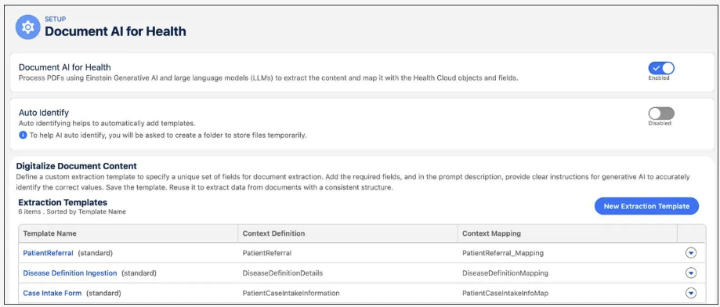
Admins can use a standard template when it fits the organization’s process. For document types outside the standard set, they can create a custom template and define the required extraction structure themselves.

Configure How a Template Extracts Data
The standard Patient Referral template brings together the configuration required to process that document type. It references a prebuilt context definition and context mapping, selects the large language model used for extraction, and provides the instructions and review settings that govern the run.
Start with the context definition, which models the information the extraction should return. It organizes that structure into nodes, attributes, and relationships.
In the Patient Referral context definition, nodes represent entities such as the patient account, the clinical service request that anchors the referral, and related clinical information. Attributes describe the values associated with those nodes. The account node, for example, includes attributes for the patient’s first name, birthdate, and gender.
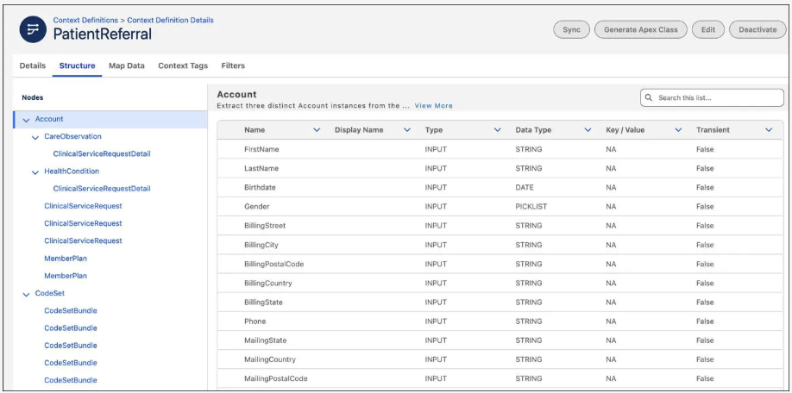
The associated context mapping connects that modelled structure to the Health Cloud data model. It links nodes and attributes from the context definition to the Salesforce objects and fields that receive the reviewed extraction results. The patient birthdate attribute, for example, maps to the corresponding field on the account record.
The context definition and mapping establish the structure and destination of the extracted data. The extraction template then configures how the feature identifies that data in a particular document type.
An extraction template includes:
- The large language model used to process the document.
- A description that provides document-level instructions and context for the extraction.
- Field prompts that tell the model what each configured attribute represents and what information to identify.
- A low-confidence threshold that determines which extracted values are flagged for additional review.
- Optional post-transform and post-save flows that extend processing at defined points in the run.
On the template page, you can view the associated context definitions and mappings, extraction flows, and field mapping prompts.
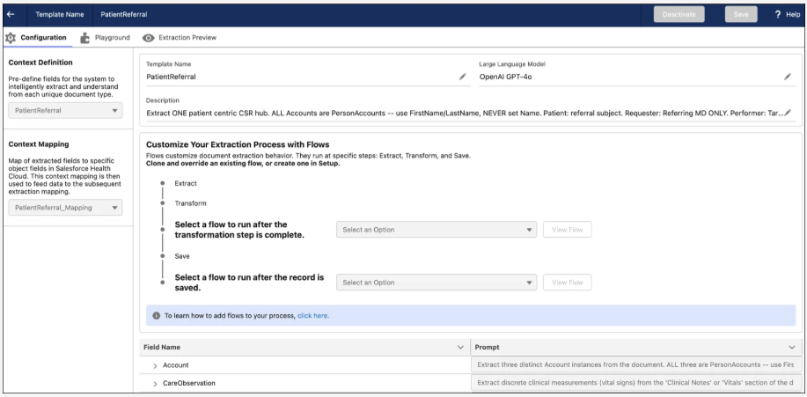
The field prompts are especially important because the context definition names the expected attributes but doesn’t explain how to recognize their values in the source document. In the Patient Referral template, the prompt for a health condition instructs the model to identify each distinct condition named in the referral, including conditions presented in a list or within narrative text.
The template-level description provides broader guidance for interpreting the document as a whole. Field prompts narrow that guidance for individual attributes. Together, they give the selected LLM the instructions to propose values for the structure supplied by the context definition.
The template also sets the low-confidence threshold. The Patient Referral template uses a threshold of 80, so any extracted field scored below 80 is flagged for additional manual review. The score directs reviewer attention; it doesn’t establish that higher-scoring values are clinically correct.
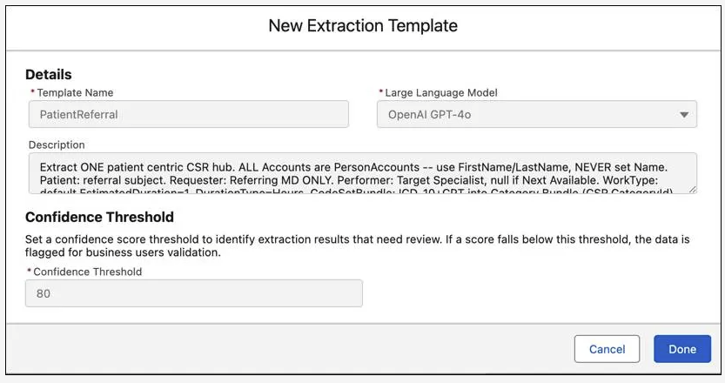
With the standard Patient Referral template, Salesforce also provides the context definition and the mapping it references. For another document type, an admin can create the required context structure and mapping, associate them with a custom extraction template, write or refine the prompts, test the results, and activate the template.

Set Up Batch Processing
The Patient Referral template can support both individually submitted documents and recurring, high-volume intake. The template still defines how each referral is extracted; batch processing changes how files enter that extraction workflow.
In Batch Document AI setup, an admin creates a batch configuration and:
- Selects the extraction template to apply.
- Identifies the connected folder that supplies the documents.
- Assigns an owner for the resulting extraction requests.
- Sets the schedule for checking and processing new files.
- Chooses whether each extraction pauses for review before saving.
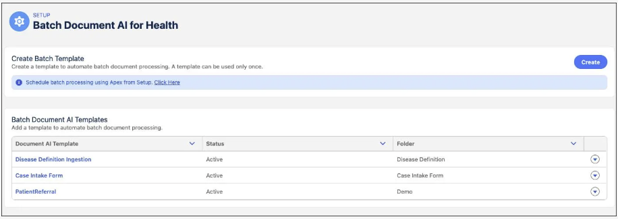
A batch job can run on a recurring schedule as frequently as every 15 minutes. When a supported document is added to the configured folder, the job submits it for processing and creates a separate document extraction request for that file.
Each document then moves through the same extraction stages used for an individually submitted request. Depending on the batch configuration, the result can pause for a user to review extracted values and resolve record matches before Salesforce saves the records.
This way, batch processing automates the repeated intake step. Teams don’t need to open the extraction interface and initiate a separate request for every incoming document. Meanwhile, each file is still individually tracked for review, troubleshooting, and audit.

Trace a Run from Document to Records
Batch processing changes how documents enter the workflow. Whether a user starts an extraction directly or a scheduled job submits it from a connected folder, Salesforce creates a Document Extraction Request for that document.
The request retains the source file and records the status of the run from extraction through saving. The related Document Extraction Request Step records track the processing stages completed for that request.
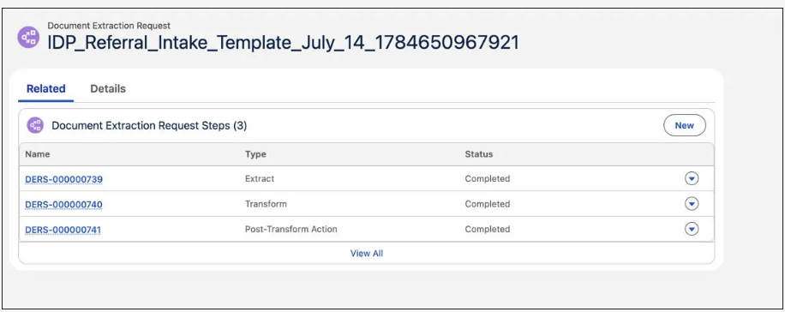
The batch run includes three core stages.
- Extract: Optical character recognition captures the source text, and the selected model uses the template instructions to propose values for the configured attributes. Each extracted value includes a confidence score.
- Transform: Salesforce organizes those proposed values according to the referenced context definition and context mapping, producing the target record structure for the document type.
- Post-transform action: Salesforce resolves references and applies matching logic so extracted entities can connect to records already in the system instead of automatically creating duplicates.

After those stages are completed, the request can pause for review. A user confirms or corrects the extracted values, resolves record matches, and saves the approved results. Salesforce then creates or updates the connected records, and the request status changes to Save Completed.
Because the request and its steps preserve the status of each stage, admins can inspect failed runs, review processing history, and rerun an extraction when needed.

Wrap Up
Document AI for Health separates document-processing configuration from day-to-day intake. Admins define how each document type is processed through templates, associated context resources, prompts, mappings, thresholds, and batch settings. Intake teams then use that configuration to extract, review, match, and save document information without rebuilding the process for each file.
Every document is individually tracked through a Document Extraction Request and its processing steps, whether the run begins with a direct upload or a scheduled batch job. That gives organizations a consistent way to process common health documents while preserving human review, record matching, and execution history.

